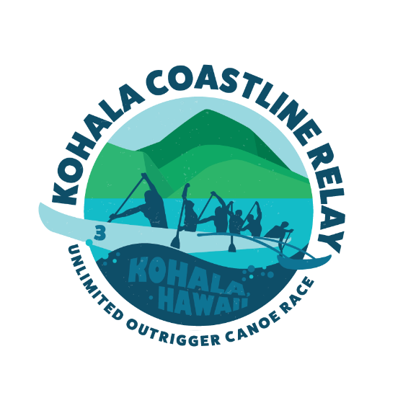

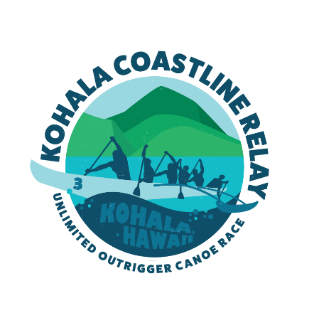
KOHALA COASTLINE RELAY
ENTRY FORM & LIABILITY WAIVER FORM
EVERY PADDLER MUST READ AND SIGN TO PARTICIPATE
I, the undersigned party, understand that outrigger paddling and water sports are physically strenuous and have inherent risks associated with it. I acknowledge potential dangers from other paddlers, canoes, motorized boats, the ocean, and the elements.
I understand that there are inherent risks associated with participating in the KOHALA COASTLINE RELAY (referred to as “Race”) that are hazardous to participants regardless of all reasonable safety measures which can be taken. Certain risks involving participation in the Race cannot be eliminated without destroying the unique character of the Race. I recognize that these risks include, but are not limited to, the following: Warm weather and heat related injuries and illnesses including dehydration, heat exhaustion, heat stroke, hypothermia and hyperthermia. I am aware of and assume all the risks associated with this paddling event, including, but not limited to, death, serious injury and loss, related to; falling, cardiac arrest, contact with other participants or objects along the course, stings from poisonous urchins, Portugese-man-o-war, jellyfish, as well as shark bites. In addition, I have been forewarned regarding safety issues, such as water entry of slippery rocks, strong currents, shallow reefs, abrasions, sprains and breaks. I understand that the above description of risks is not complete and that unknown or unanticipated Race risks may result in injury, illness or death. I certify that I am physically and mentally fit, have trained sufficiently in similar conditions to participate in this event, and have not been advised otherwise by a qualified medical person. Having read and understood this waiver, I hereby expressly waive and release Hulakai, SJ SURF PRODUCTS, Aloha Unlimited Productions, Kristin Old and their respective heirs, agents, representatives, employees and/or sponsors (collectively the “Sponsors”), from any and all rights and claims for injury or damages which may hereafter accrue to me arising from or caused by any risks inherent in the Race. I agree to indemnify and hold harmless the Sponsors from all claims, damages, losses, injuries, and expenses that may arise from or be caused by risks inherent in the Race or from any negligent or intentional acts, which I may perform. I understand that the ocean and the beaches in which the race transition will occur will remain open during the race and I will to the best of my ability be safe and if I choose otherwise it will be done at my own discretion. Also, by signing this waiver you allow the Hulakai, Aloha Unlimited Productions, Ocean Paddler TV to use pictures and video of the event for future promotions.
CANOE NAME & CANOE NUMBER: ______________________________________________
CANOE CLUB/TEAM NAME: ___________________________________________________
Entry Fee: $30 x 18 = $540 _________ Cash
Sum of Ages of Participants: ____________
Category: _____ Sum of Ages > 756 ______ Sum of Ages < 756 ______ Juniors/Sum of Ages < 324

I HAVE CAREFULLY READ, CLEARLY UNDERSTAND, AND VOLUNTARILY SIGN THIS WAIVER AND RELEASE AGREEMENT
MEN’S LEG:
PRINTED NAME (Participant & Guardian, if applicable) | SIGNATURE of participant or guardian: | Tee shirt Size | Age: | Emergency Contact & Phone #
WOMEN’S LEG:
PRINTED NAME (Participant & Guardian, if applicable) | SIGNATURE of participant or guardian: | Tee Shirt Size | Age: | Emergency Contact & Phone #
MIXED LEG:
PRINTED NAME (Participant & Guardian, if applicable) | SIGNATURE of participant or guardian: | Tee Shirt Size | Age: | Emergency Contact & Phone #

